Instructions for Husky’s Aluminum Angle Berm

- Remove the berm liner from the storage bag
- Unroll and spread the berm out flat and fold the sides in. Your berm should now be it’s actual size
- Remove the aluminum angles from their bag. The angles are bent at 90 degrees
- There are pockets RF welded to the sides vertically around the outside perimeter of the berm approximately 24” apart. These will accept the angles. (See figures 1A & 1B)
- With the side of the berm folded in, pockets facing up, slide each angle into a pocket from the bottom going towards the top edge of the berm. The exposed part of the angle that is not in the pocket should be directed underneath the berm. (see figures 2A & 2B)
- With the angles installed you can now erect the sides creating a 90 degree wall around the perimeter of the berm. The part of the angle that is not in the pocket should be underneath the berm.
- Pull the sides out removing any wrinkles in the floor and your berm is ready for use. (see figures 3A & 3B)
- To enter or exit just remove as many angles as needed and fold the side down.
Figure 1 A Figure 1 B
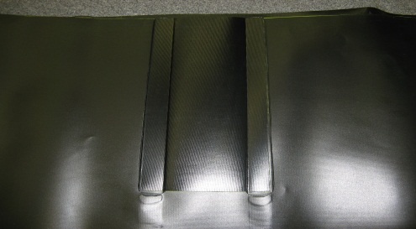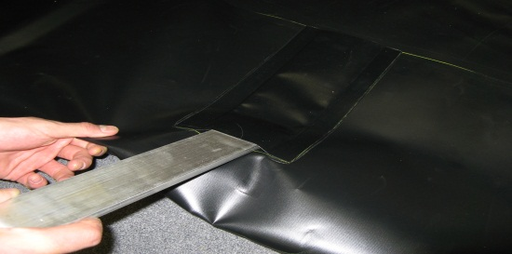

F Figure 2 A Figure 2 B

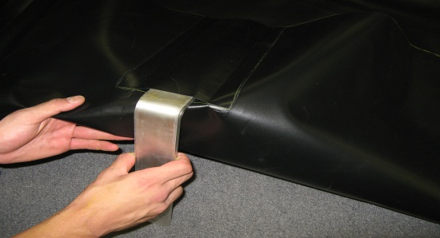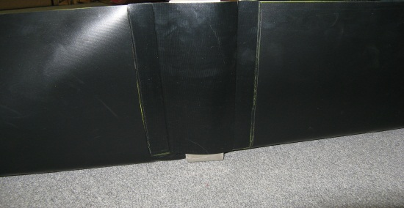

Figure 3 A Figure 3 B
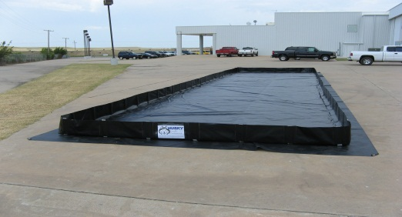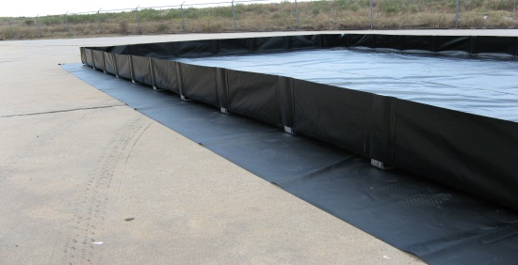
Husky Portable Containment 1-800-260-9950 “Leader of the Pack” wwww.huskyportable.com

