Instructions for the “Super Berm”
- Remove the Super Berm from the storage bag
- Unroll and spread the berm out flat and fold the sides in.
DO NOT PULL ON THE FOAM COLLAR OR THE TOP EDGE OF BERM WHEN SPREADING YOUR BERM OUT. BE EXTREMELY CAREFUL TO PULL ON THE FLOOR AREA NOT THE TOP EDGE. THESE BERMS ARE HEAVY AND BY PULLING ON THE FOAM COLLAR OR TOP EDGE OF THE BERM CAN RESULT IN DAMAGE TO THE CORNERS AND WILL VOID THE WARRANTY
- Remove the aluminum angles from the storage bag. The angles are bent to 90 degrees.
- There are pockets heat sealed to the sides vertically approx. every two feet. These will accept the angles. (see figure 1A & 1B)
- With the sides folded in, pockets facing up, slide each angle into a pocket from the bottom going towards the top edge of the berm. The exposed part of the angle that is not in the pocket should be directed underneath the berm. (see figures 2A & 2B)
- With the angles installed you can now stand the sidewalls up creating a 90 degree wall down the sides.
- The end walls are self-rising so they have no assembly. Be sure all the wrinkles are pulled out of the floor area and you berm is ready for use.
- DO NOT PULL ON THE FOAM COLLAR OR THE TOP EDGE OF BERM WHEN SPREADING YOUR BERM OUT. BE EXTREMELY CAREFUL TO PULL ON THE FLOOR AREA NOT THE TOP EDGE. THESE BERMS ARE HEAVY AND BY PULLING ON THE FOAM COLLAR OR TOP EDGE OF THE BERM CAN RESULT IN DAMAGE TO THE CORNERS AND WILL VOID THE WARRANTY
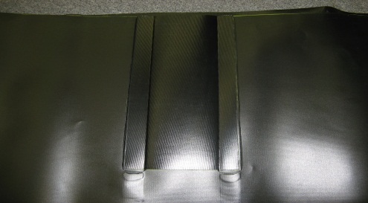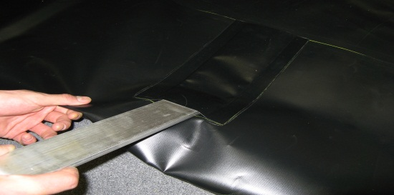
Figure 1A Figure 1B
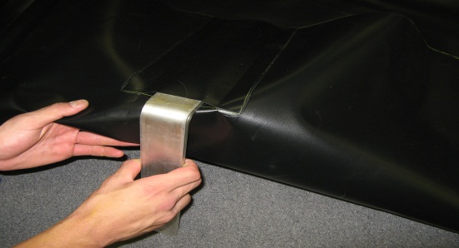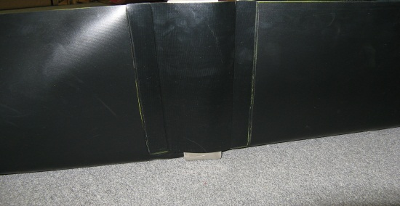
Figure 2A Figure 2B
Husky Portable Containment 1-800-260-9950/918-333-2000
“Leader of the Pack”
www.huskyportable.com

